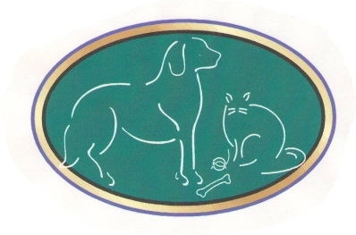
Welcome to Graham Animal Hospital

Primary Pet Owner Information

Name: ___________________________________________ Driver’s License #:______________
Address:_______________________________________________________________________
City:____________________________________ State:_______________ Zip:______________
Email:_____________________________________________ Employer: ___________________

Primary Phone: _________________________________ Circle one: Home Work Cell
Secondary Phone: _______________________________ Circle one: Home Work Cell
Additional Contact Numbers: ____________________________________________________

Secondary Pet Owner

Name: ___________________________________________ Driver’s License #:______________
Primary Phone: _________________________________ Circle one: Home Work Cell
Secondary Phone: _______________________________ Circle one: Home Work Cell
Is this person allowed to make financial and medical decisions for all pets? Yes No

How did you hear about our practice? A friend Online Yellow Pages Driving by

We would like to welcome you and your pet(s) to Graham Animal Hospital. In order to provide the best health care possible, we require every dog/cat be vaccinated for Rabies and Distemper (DHLP-Parvo/FVRCP). Dogs that will be boarding with us are also required to have a Bordetella/Kennel Cough (BV). It is also our policy to administer a CAPSTAR tablet to all pets that stay in our office. Capstar tablets protect your pet from fleas while in our hospital. For your convenience, we offer morning and afternoon appointments as well as a drop off service.

All Fees are due at the time services are rendered. We don’t have a billing system!!! However, we do accept cash, check, Care Credit, Discover, Visa and Master Card. A deposit will be required for emergencies and certain medical services. We will also provide a written estimate for any service upon your request.

Signature: __________________________________________ Date: ____________________

